**rmudenur**

**ToDo Manager Application**

Technologies

1. Spring 3.x

2. MongoDB

3. Thymeleaf

4. Js, Jquery and Bootstrap

5. Maven

**Build**

1. Use maven command --> mvn clean:clean

2. mvn eclipse:clean

3. mvn compile:war

Deploy the war to check the UI.

Context -- name **--> ToDoManager**

Below are the screen shots of application

Use Case 1 : View List

Use the URL --> http://localhost:8080/ToDoManager

This takes you to the home page where it displays the list of ToDo data present for the user

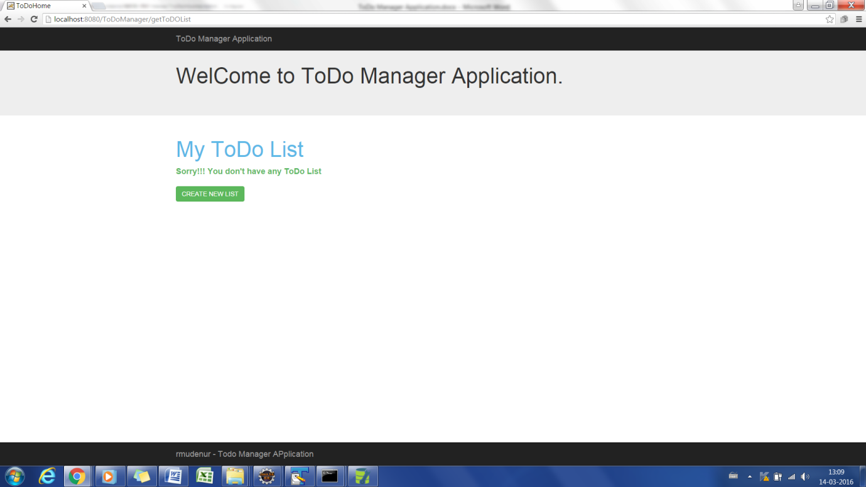

1. Create New List

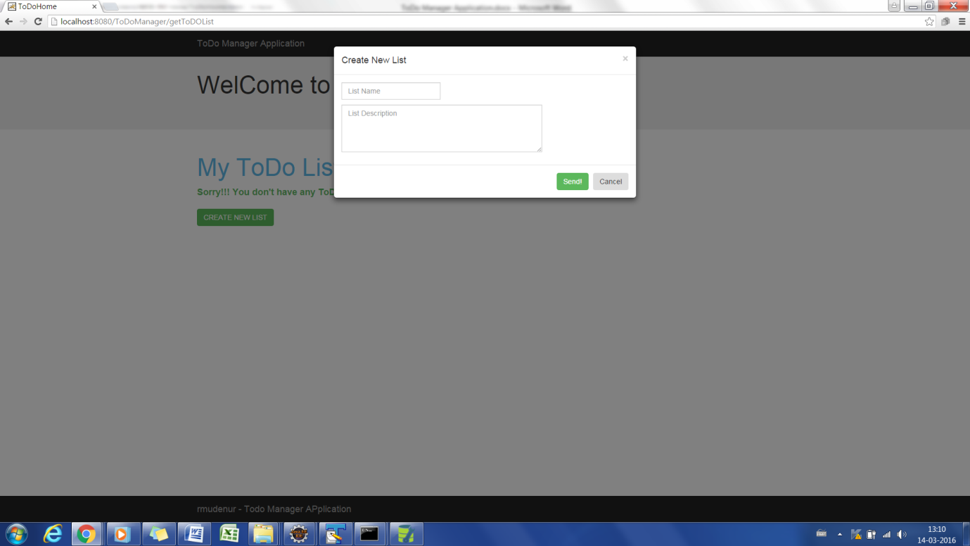

2. Post the Data

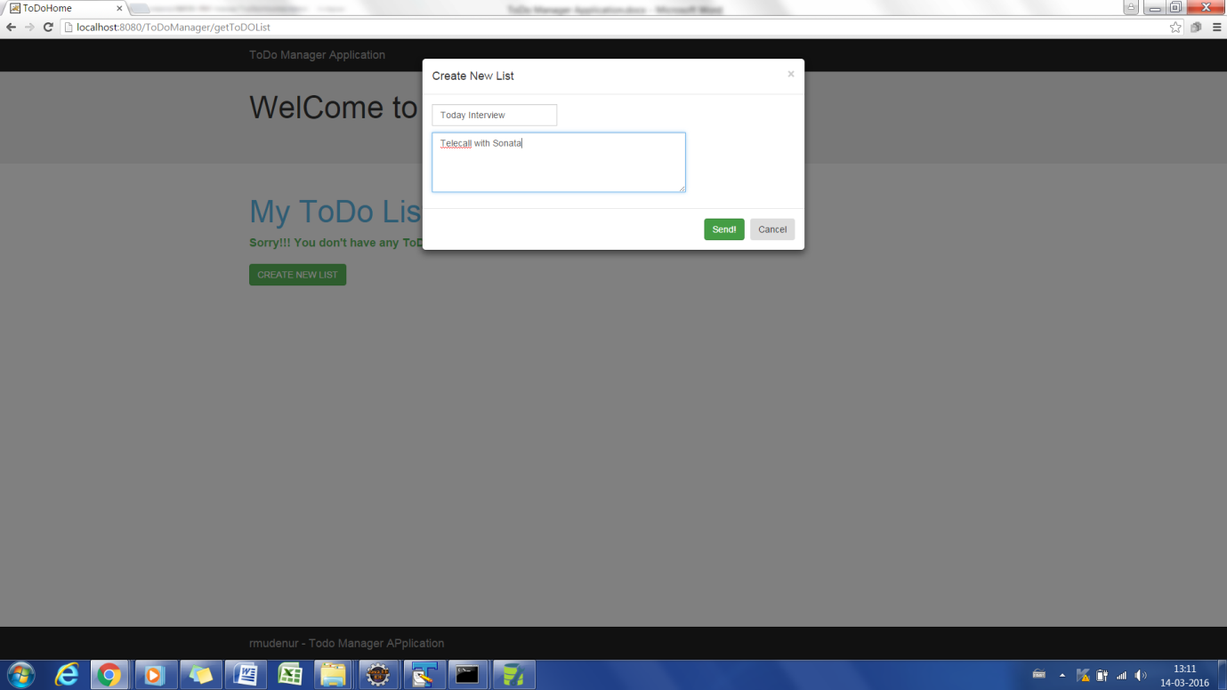

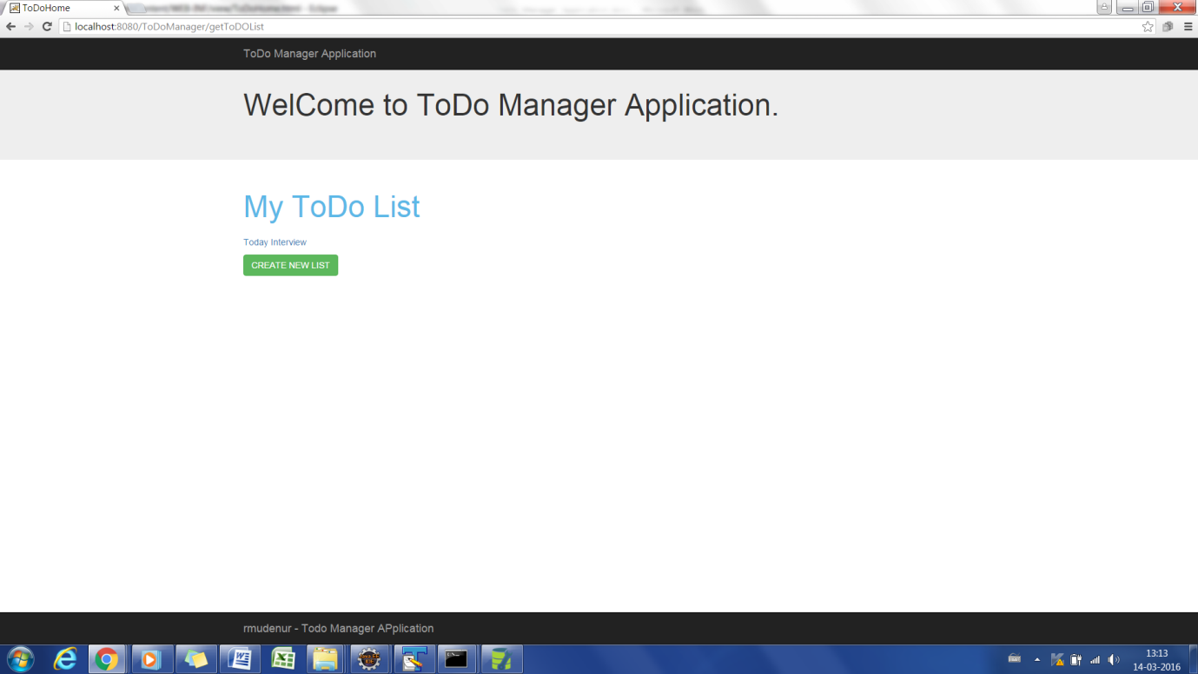

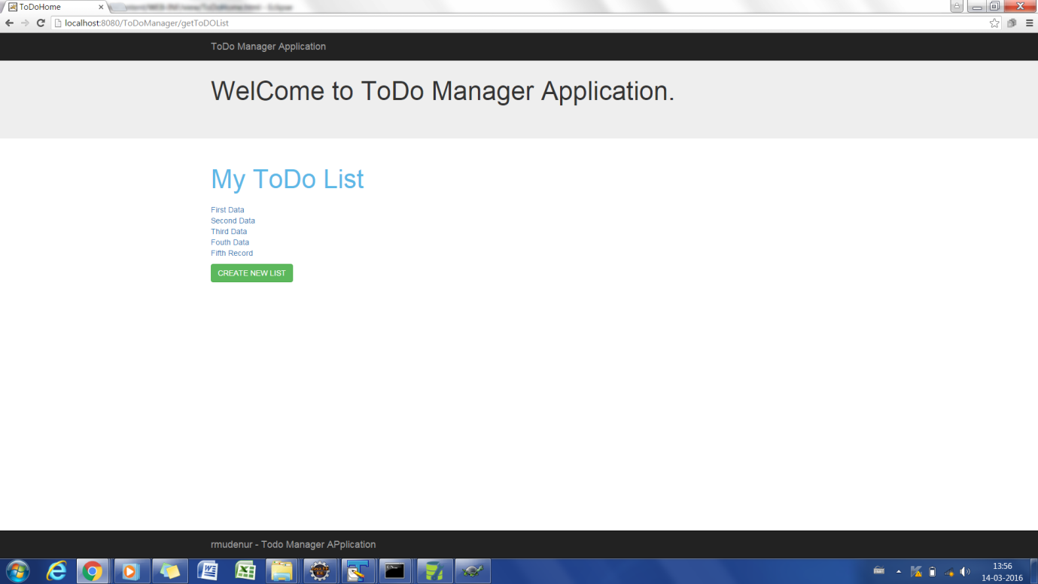

Edit -

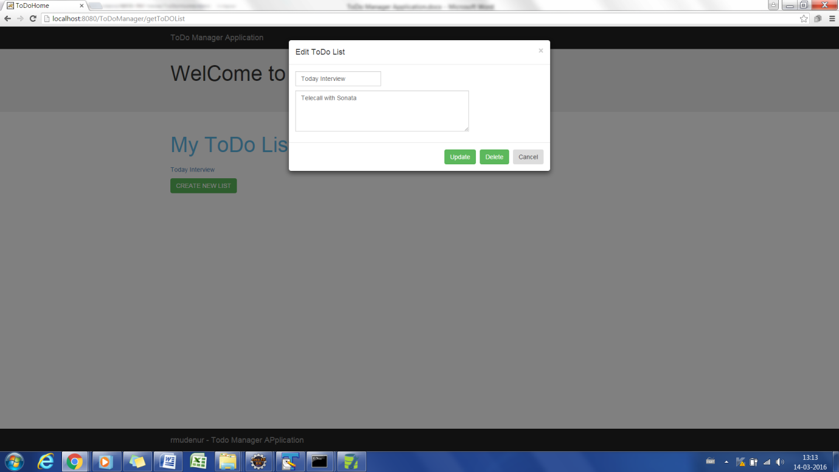

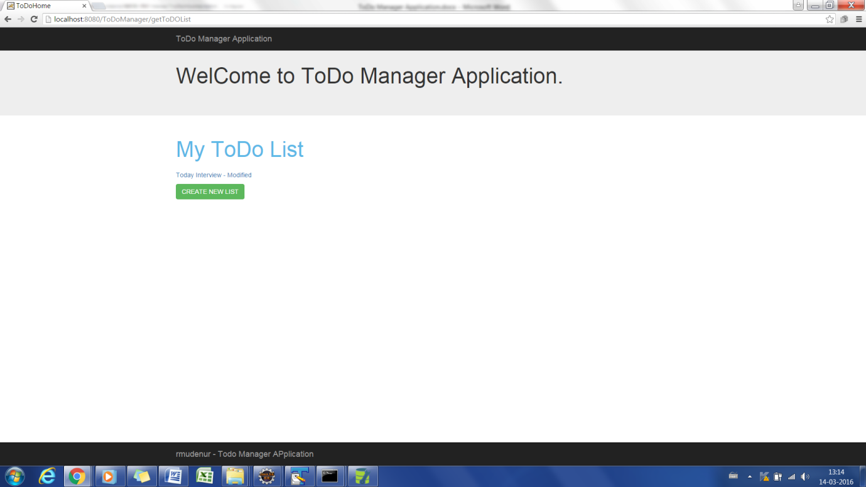

Delete

